**OBJECTIVE**

**1. What is the total number of tables present in the data?  
 Ans:** There are 23 tables.

**2. What is the total number of attributes present in the data?  
 Ans:** Total attributes present in data is 28. ( consultationType, Website, refundStatus, isWhiteListUser, chatSeconds, queue, freeCall, freeChat, createdAT, updatedAt, __v, statementEntryId, chatStartTime, chatEndTime, timeDuration, callChannel, callIvrType, callStatus, CallSid, Amount,astrologerCallStatus, astrologerOnCallDuration, astrologersEarnings, netAmount, region, userCallStatus, userOnCallDuration, rating)

**3. The data consists of some inconsistent and missing values, so ensure that the data used for further analysis is cleaned.  
 Ans:**

1. Selected Relevant Columns  
   Extracted only necessary fields like Consultation Type, Guru Name, Date & Time, Status, Rating, Amount, etc., using formulas like **FILTER()** or **xloop.**
2. Filtered Only 'Call' and 'Chat' Records  
   Removed unrelated types (e.g., Complementary, Public Live Call) using:

**=FILTER(data!A:Z, (data!H:H="Call") + (data!H:H="Chat"))**

1. Converted ISO Date Format  
   Used:

**=TEXT(createdAt, "yyyy-mm-dd")**

to extract clean date from timestamps.

1. Created Time Buckets (Shifting Time)  
   Applied HOUR() logic to classify records into:
   * 12:00 AM – 08:00 AM
   * 08:00 AM – 04:00 PM
   * 04:00 PM – 12:00 AM

Used Formula:

**=IF(AND(HOUR(F2)>=0,HOUR(F2)<8), "12:00 AM - 08:00 AM", IF(AND(HOUR(F2)>=8,HOUR(F2)<16), "08:00 AM - 04:00 PM", "04:00 PM - 12:00 AM"))**

1. Created Status Column for Success/Failure If the chat status is not completed its show **failure** and if call Status is busy, incomplete its show as **failure** only in case of completed its show as **Completed**  
   Formula used:

**=IF(OR(EXACT(chatStatus, "completed"), EXACT(callStatus, "completed")), "success", "failure")**

to unify status classification.

1. Extracted Unique Guru ID and User ID  
   Used Pivot Tables to list unique Guru ID and User ID for summary and analysis.

**4. What is the change in daily call volume day by day, and also find the average daily call volume?  
 Ans:** According to data I have daily call volumes from 2023-12-01 to 2024-01-03 — a total of 34 days.

Grand Total of Call Volumes: 8,508

Average Daily Call Volume: 250.24

Biggest drop: -122 calls on 2023-12-14

Biggest spike: +150 calls on 2023-12-0

|  |  |  |
| --- | --- | --- |
| **Date** | **Count of Consultation Type** | **Change From Previous Day** |
| 2023-12-01 | 372 |  |
| 2023-12-02 | 333 | -39 |
| 2023-12-03 | 383 | 50 |
| 2023-12-04 | 364 | -19 |
| 2023-12-05 | 253 | -111 |
| 2023-12-06 | 254 | 1 |
| 2023-12-07 | 254 | 0 |
| 2023-12-08 | 138 | -116 |
| 2023-12-09 | 288 | 150 |
| 2023-12-10 | 430 | 142 |
| 2023-12-11 | 424 | -6 |
| 2023-12-12 | 358 | -66 |
| 2023-12-13 | 348 | -10 |
| 2023-12-14 | 226 | -122 |
| 2023-12-15 | 276 | 50 |
| 2023-12-16 | 258 | -18 |
| 2023-12-17 | 185 | -73 |
| 2023-12-18 | 233 | 48 |
| 2023-12-19 | 209 | -24 |
| 2023-12-20 | 178 | -31 |
| 2023-12-21 | 159 | -19 |
| 2023-12-22 | 163 | 4 |
| 2023-12-23 | 241 | 78 |
| 2023-12-24 | 232 | -9 |
| 2023-12-25 | 258 | 26 |
| 2023-12-26 | 255 | -3 |
| 2023-12-27 | 242 | -13 |
| 2023-12-28 | 181 | -61 |
| 2023-12-29 | 258 | 77 |
| 2023-12-30 | 179 | -79 |
| 2023-12-31 | 158 | -21 |
| 2024-01-01 | 115 | -43 |
| 2024-01-02 | 196 | 81 |
| 2024-01-03 | 107 | -89 |
| **Grand Total** | **8508** |  |

**5. Which months experienced the highest and lowest call volumes?  
 Ans:** December 2023: 8,090 calls January & 2024 (partial, only 3 days): 418 calls.

January's data is incomplete (only 3 days), so its total is naturally lower. If comparing full months, December is the only complete one in this data.

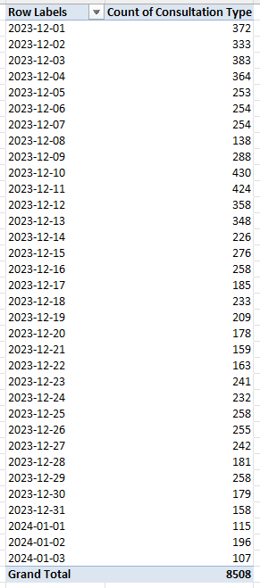

**“According to the pivot table, December 2023 recorded the highest call volume with 8,090 calls, while January 2024 shows lower numbers due to incomplete data."**

**6. What is the total operational cost for that month?  
 Ans:**

**Total earnings in December 2023 (full month)** = ₹93,786.16

**Total earnings in January 2024 (only 3 days)** = ₹5,360.41

**Grand Total** = ₹99,146.57

|  |  |
| --- | --- |
| **Row Labels** | **Sum of astrologersEarnings** |
| **2023** | **93786.16295** |
| **Dec** | **93786.16295** |
| **2024** | **5360.408** |
| **Jan** | **5360.408** |
| **Grand Total** | **99146.57095** |

**7. What is the average number of calls handled per agent per day?  
 Ans:** The total "Count of ID" is 8,508 calls, handled by 128 unique agents over 34 unique days (December 1, 2023, to January 3, 2024). The average is calculated as 8,508 ÷ (128 × 34) = 8,508 ÷ 4,352 ≈ 1.955, rounded to 1.96 calls per agent per day.

|  |  |
| --- | --- |
| **Row Labels** | **Count of ID** |
| **Aachary Prateek** | **18** |
| 2023-12-01 | 1 |
| 2023-12-03 | 8 |
| 2023-12-04 | 2 |
| 2023-12-10 | 1 |
| 2023-12-11 | 3 |
| 2023-12-14 | 2 |
| 2023-12-15 | 1 |
| **Acharya Arti S** | **13** |
| 2023-12-12 | 3 |
| 2023-12-16 | 5 |
| 2023-12-17 | 3 |
| 2023-12-31 | 2 |

(This table is for showcase only and does not present all the data. Click on the link for the full data table [Book3.xlsx](https://1drv.ms/x/c/b9b4808ba6279557/EVcv2kRttP9Bt82cFm_BcUwByF8iw-RNyIlNGK1JxHAFzw?e=FFsA9s))

**8. How many repeat callers are there, and what percentage of total calls do they represent?**

**Ans:** Repeat Callers = 1,277

Total Calls by Repeat Callers = 6,156

If we want to repeat call then we need to subtract the first call: (6156-1277) = 4879

Total Callers (unique) = 3629

Total Calls (all calls made) = 8,508

Percentage of Total Calls by Repeat Callers: (4879/8508) ×100 = 57.34%

Repeat Callers: 1,277

They account for: 57.34% of all calls

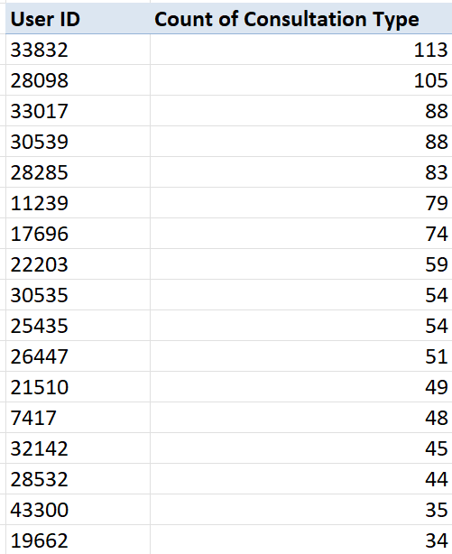

**9. What are the total sales generated by the call centre for each product category?  
 Ans:** Call: 168520.6 INR, Chat: 45494.6 INR.

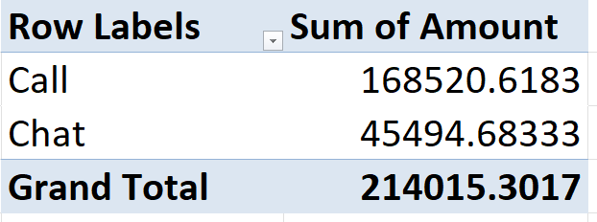

**10. How many calls were made for each user ID and guru ID?  
 Ans:**

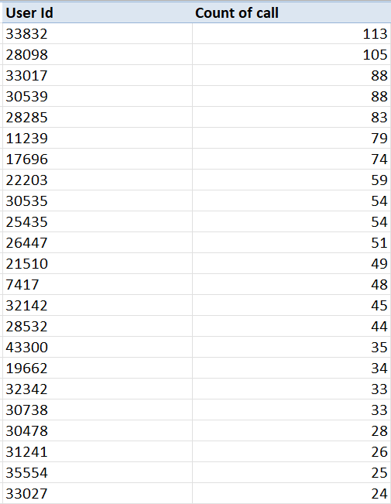

(These two tables only for showcase and does not present all the data. Click on the link for the full data [ASTRO ANALISIS BY A.K (1) (1).xlsb](https://1drv.ms/x/c/b9b4808ba6279557/EQfLOHUwXc9JoW2N-t_XJrwBjVVDiFsc0ouJp9bVZTStqA?e=mAf8fm) work sheet name **customer details** )

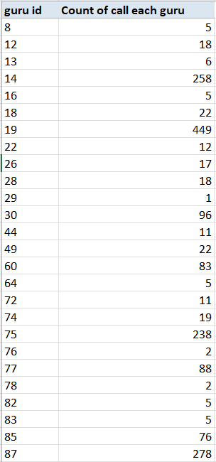

(These two tables only for showcase and does not present all the data. Click on the link for the full data [ASTRO ANALISIS BY A.K (1) (2).xlsb](https://1drv.ms/x/c/b9b4808ba6279557/EUYJMtZq6opKlMGRJVWfmY0BK1-Ria7ub9Zswfjf-HW70Q?e=Jd8MLB) work sheet name **guru details**)

**11. What is the correlation between call duration and customer satisfaction?  
 Ans:** 0.36678

**Approch:**

|  |  |  |
| --- | --- | --- |
| **Row Labels** | **Average of userOnCallDuration** | **Average of rating** |
| Aachary Prateek | 12.22222222 | 3.388888889 |
| Acharya Arti S | 94.84615385 | 4 |
| Acharya Dev | 239.6666667 | 3.666666667 |
| Acharya Shastri | 80 | 3.428571429 |
| Aham T | 110.6190476 | 3.19047619 |

(Full table Link [Copy of Copy of Copy of Copy of Copy of ASTRO ANALISIS BY A.K (1) (2).xlsb](https://1drv.ms/x/c/b9b4808ba6279557/EbjxtDKmQztBkVjD1WQJATIBadx1_YEMPMC0geqWjq0RAQ?e=caP1LX))

The correlation between call duration and customer satisfaction I use “= **CORREL( select useroncalldurtion column, select averageof rating column )**”

For Corelation between call duration and customer satisfaction

**12. Which guru has the highest and lowest customer satisfaction scores?  
 Ans**: **Guru:** *Astro Pujaa Rai* and *Tarot Mystical*  
**Average Rating:** **7.5**These two gurus have received the highest average ratings, indicating strong customer satisfaction and positive feedback across their consultations.

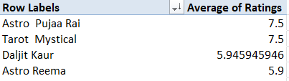

**Guru:** *gurucool support* and *Tarot Rittika* **Average Rating: 0**

These gurus received a 0 rating, which suggests very poor or no customer feedback, indicating either dissatisfaction or missing/incomplete data.

|  |  |
| --- | --- |
| **Row Labels** | **Average of Ratings** |
| gurucool support | 0 |
| Tarot Rittika | 0 |
| (These two tables only for showcase and does not present all the data. Click on the link for the full data. [Book2.xlsx](https://1drv.ms/x/c/b9b4808ba6279557/Edar8XaaYB5Iq5sdR0OLbN0BW5xO_ncfnuNAdrHfFrJlXQ?e=PtLFGN)) |  |

**13. What is the average customer satisfaction score by month?  
 Ans:**

|  |  |
| --- | --- |
| **Row Labels** | **Average of Ratings** |
| 2023 | 2.949637572 |
| 2024 | 2.676413255 |

**14. How many categorical columns are there in the data?  
 Ans:** There are 13 categorical columns in the data. (consultationType, website, refundStatus, isWhiteListUser, queue, freeCall, freeChat, callChannel, callIvrType, callStatus, astrologerCallStatus, region, userCallStatus)

**SUBJECTIVE**

**1. Should the investment be used to hire more agents, improve training programs, or upgrade call center technology?**

**Ans:**

**Reference**

**Source Files / Charts Used:**

1. **Average of Ratings**

|  |  |
| --- | --- |
| **Guru ID** | **Average of Ratings** |
| 8 | 4.2 |
| 11 | 2.333333333 |
| 12 | 3.555555556 |
| 13 | 2.72972973 |
| 14 | 2.725 |
| 16 | 3.4 |
| 18 | 2.861111111 |

**→ Pivot table** [**Copy of Copy of Copy of Copy of Copy of ASTRO ANALISIS BY A.K (1) (2) (1).xlsb**](https://1drv.ms/x/c/b9b4808ba6279557/EbcEmDPNjtFGrPHPY3VJfhYBpb0LOSGdvY1YAink99OVHA?e=ztbLNt) **( showing average user ratings per expert (Grand Total Rating = 2.93)**

1. **Call Duration & Ratiings**

|  |  |  |
| --- | --- | --- |
| **Row Labels** | **Average of userOnCallDuration** | **Average of rating** |
| Aachary Prateek | 12.22222222 | 3.388888889 |
| Acharya Arti S | 94.84615385 | 4 |
| Acharya Dev | 239.6666667 | 3.666666667 |
| Acharya Shastri | 80 | 3.428571429 |
| Aham T | 110.6190476 | 3.19047619 |

**→ Pivot showing both call duration and rating per expert** [**Copy of Copy of Copy of Copy of Copy of ASTRO ANALISIS BY A.K (1) (2) (1).xlsb**](https://1drv.ms/x/c/b9b4808ba6279557/EbcEmDPNjtFGrPHPY3VJfhYBpb0LOSGdvY1YAink99OVHA?e=ij5yKX) **(Avg Call Duration = 118.74 mins, Avg Rating = 3.50)**

1. **Donut Charts – Call vs Chat Progress**

**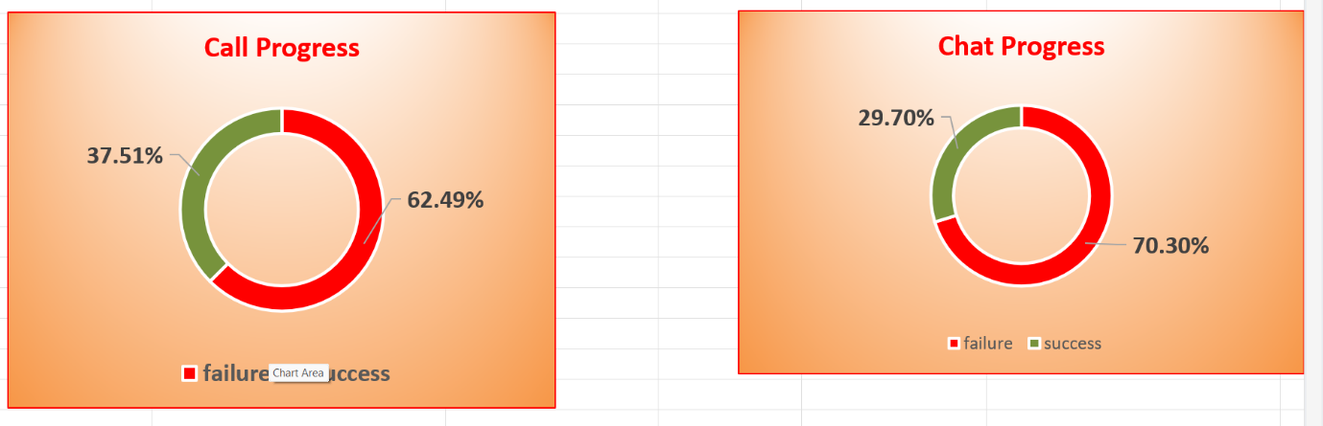  
→ Visualizing success and failure percentages**

* + **Call Success: 37.51%**
  + **Chat Success: 29.70%**

**Approach Used**

1. **Excel Pivot Tables:**
   * Calculated the average userOnCallDuration and rating per expert
   * Compared call durations with satisfaction scores
2. **Data Matching:**
   * Cross-referenced experts who had *high ratings but no call time* and vice versa to identify technical issues or tracking problems
3. **Visualization Analysis:**
   * Used donut charts to examine overall success/failure in chat and call channels
4. **Performance Comparison:**
   * Evaluated the distribution of engagement (call mins) across experts
   * Noted performance gaps using conditional formatting

**Insights (Key Findings)**

* **System failure is high:**62.49% of call interactions and 70.30% of chat interactions failed — this is much higher than normal industry rates
* **Data inconsistencies:**Several experts have ratings recorded despite 0 call minutes, suggesting tech issues with data logging or routing
* **Inefficient agent utilization:**Some agents have extremely low or extremely high average call durations (0 to 300+ mins), which indicates that resource distribution is uneven
* **Training inconsistency:**Rating variation is wide (2.6 to 5) for similar call durations — pointing to inconsistent quality in customer service
* **Tracking improved ratings:**The dataset with call durations (avg 3.50 rating) shows higher satisfaction than the one with just ratings (avg 2.93 rating) — suggesting proper tracking improves performance feedback

**Suggestions**

1. **Upgrade call center technology first**
   * The high failure rates in both calls (62.49%) and chats (70.30%) indicate a strong need to improve system infrastructure such as routing, tracking, and chat servers.
2. **Implement skill-based training programs**
   * After addressing technical issues, training should be focused on agents with low ratings (below 3 stars) or unusually long call durations to standardize service quality.
3. **Delay hiring new agents**
   * Current data shows uneven agent utilization and underperformance due to system inefficiencies. Hiring more agents now would be ineffective until the platform issues are resolved.

**Conclusion**

* Investment should first go toward upgrading call and chat center infrastructure, followed by performance-based training programs.
* New agent hiring can be considered later after stabilizing current operations and boosting success rates above 60%.

1. **What are the potential risks of each investment option (hiring, training, technology upgrades), and how can they be mitigated?**

**Ans:**

📊 Reference:

* Failure chart by shift

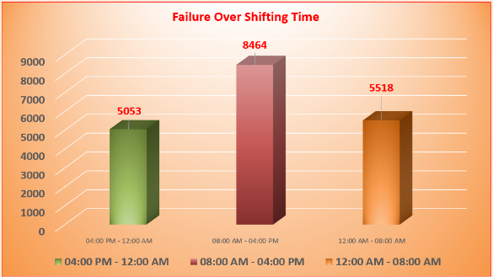

* Call Volume According to Shifting Hours

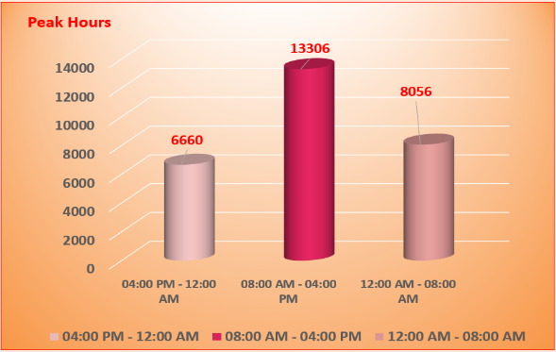

* Average rating and consultation type charts

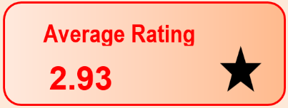

* Revenue and cost summary data (Income = ₹2,14,015 | Astrologer Earnings = ₹99,146 | Profit ≈ ₹1,14,868)

🔍 Approach Used:

We analysed call volume, rating trends, and shift-wise failures, along with the profit margin, to identify which investment option poses what kind of risk and how those risks can be minimized.

⚠️ Potential Risks & Mitigation per Option:

1. Hiring More Staff
   * Risks:
     + Increased operational cost may reduce the current high profit (~₹1.14 lakh).
     + Possibility of hiring underperforming or low-rated consultants, increasing failure rate.
   * Mitigation:
     + Hire selectively for high-failure time shifts (as shown in failure chart).
     + Start with part-time or hourly consultants to keep costs flexible.
2. Training Existing Staff
   * Risks:
     + Investment in training might not guarantee improvement in ratings or revenue.
     + Downtime during training may reduce availability.
   * Mitigation:
     + Focus training on consultants from low-rated shifts or types
     + Track post-training performance to measure ROI.
3. Technology Upgrades
   * Risks:
     + High upfront cost with unclear short-term impact.
     + Staff may take time to adapt to new tools, reducing productivity temporarily.
   * Mitigation:
     + Prioritize low-cost tools like scheduling/CRM improvements first.
     + Pilot upgrades in one shift or team before full rollout.

✅ Suggestions:

* Begin with targeted training programs for low-rated or high-failure shifts.
* Analyze cost-effectiveness before hiring; only expand headcount for peak load periods.
* Use current profits to reinvest gradually in tech that supports automation or reduces call/chat failure.

1. **How does AstroSage's call center performance compare to AstroGuru's average call volume, customer satisfaction, and agent performance?**

**Ans:** AstroGuru does not provide any publicly available data regarding call volume, customer satisfaction, or agent performance. So, a direct comparison is not possible.

1. **How can the call center improve its handling of peak call periods to ensure high customer satisfaction?**

**Ans:**

📊 Reference:

* Failure Over Shifting Time chart

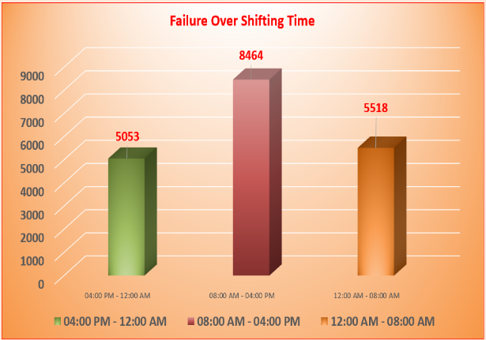

* Average Rating (2.93), Consult Success (43.53%)

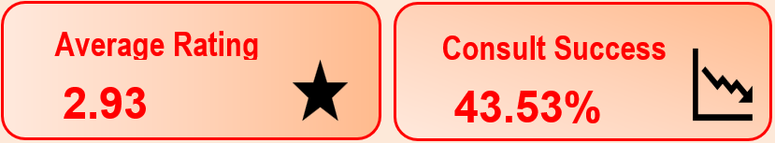

* Guru-wise consultation count , Average Ratings, Revenue split by Call/Chat

Guru-wise Consultation Count(Take the Data From work sheet Guru Details in excel [ASTRO ANALISIS BY A.K.xlsb](https://1drv.ms/x/c/b9b4808ba6279557/EXr5grvpDYBBnVUP5-0a8Z0Binq9hBk8_lZHeytN4CNvcw?e=50cQiS))

|  |  |
| --- | --- |
| **Row Labels** | **Count of Consultation Type** |
| Aachary Prateek | 146 |
| Acharya Arti S | 13 |
| Acharya Dev | 60 |
| Acharya Shastri | 7 |
| Acharya Divyansh | 111 |
| Aham T | 98 |
| Astro Aacharya Dev | 8 |
| Astro Aditya | 107 |
| Astro Aditya N | 293 |
| Astro Akash | 4 |
| Astro Anaya | 16 |
| Astro Anju | 6 |
| Astro Ashok | 619 |
| Astro Brejesh | 1070 |
| Astro Dr Shrey | 177 |
| Astro Gurdeep | 26 |
| Astro Jha | 183 |

Average Rating Count(Take the Data From work sheet Guru Details in excel [ASTRO ANALISIS BY A.K.xlsb](https://1drv.ms/x/c/b9b4808ba6279557/EXr5grvpDYBBnVUP5-0a8Z0Binq9hBk8_lZHeytN4CNvcw?e=50cQiS))

|  |  |
| --- | --- |
| **Row Labels** | **Average of Ratings** |
| Aachary Prateek | 3.109589041 |
| Acharya Arti S | 4 |
| Acharya Dev | 2.516666667 |
| Acharya Shastri | 3.428571429 |
| Acharya Divyansh | 0.387387387 |
| Aham T | 4.785714286 |
| Astro Aacharya Dev | 3 |
| Astro Aditya | 0.794392523 |
| Astro Aditya N | 3.706484642 |
| Astro Akash | 2.75 |
| Astro Anaya | 2.875 |
| Astro Anju | 3.333333333 |
| Astro Ashok | 4.172859451 |
| Astro Brejesh | 1.894392523 |
| Astro Dr Shrey | 3.559322034 |
| Astro Gurdeep | 2.923076923 |

* Failure over Shifting Time, Consultation Type Count

Failure over Shifting Time

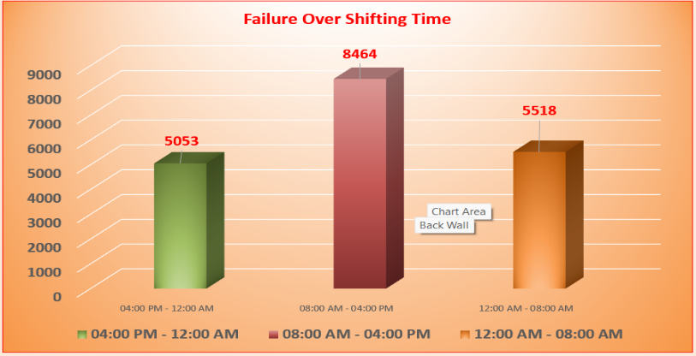

Consultation Type Count

|  |  |
| --- | --- |
| **Consultation Type Count** | |
| **Row Labels** | **Count of Consultation Type** |
| Call | 8508 |
| Chat | 19514 |
| **Grand Total** | **28022** |

🧠 Approach Used:

1. Analyzed the shift-wise failure chart to identify peak problem periods.
2. Examined consultation counts and revenue contribution from different time slots.
3. Compared this with average ratings and success rates to correlate performance issues.
4. Identified root causes during peak hours using performance and workload data.

📌 Insights as Key Pointers:

1. Failure Volume Is Highest During 08:00 AM – 04:00 PM:
   * This shift alone recorded 8464 failures, nearly 40% higher than other shifts.
2. High Call Volume, But Poor Handling:
   * Despite peak consultation traffic during this time, average ratings remain low.
   * Suggests overloaded or underperforming agents.
3. Agent Distribution Is Uneven:
   * Few agents handle bulk of calls; many others have low consultation counts.
   * Indicates poor workload balancing.
4. Poor Consultation Success Rate (43.53%):
   * Suggests lack of timely resolution or disconnections during peak hours.

✅ Suggestions:

1. Shift-Based Resource Planning:
   * Assign more high-performing agents during 08:00 AM – 04:00 PM.
   * Use real-time dashboards to monitor traffic spikes.
2. Load Balancing Across Agents:
   * Distribute consultations more evenly using round-robin algorithms or queue optimizers.
   * Encourage use of chat consultation (lower failure rate).
3. Incentivize Peak Performance:
   * Introduce shift-based incentives or bonuses for Gurus who maintain high ratings during rush hours.
4. Tech Interventions:
   * Implement AI-based chatbots to manage basic queries or triage customers during overflow.
   * Reduce human load on routine or low-priority calls.
5. Training & SOPs for Peak Handling:
   * Create specific training modules for handling peak-hour stress, multitasking, and time efficiency.
6. Monitor & Rotate Low Performers:
   * Gurus consistently underperforming during peak hours should be either retrained or reallocated.
7. **Based on historical data, what strategic initiatives should be prioritized to improve efficiency and customer satisfaction?**

**Ans:**

**Reference:**

* Guru-wise Consultation Count

|  |  |
| --- | --- |
| **Guru-wise Consultation Count** | |
| **Row Labels** | **Count of Consultation Type** |
| Aachary Prateek | 146 |
| Acharya Arti S | 13 |
| Acharya Dev | 60 |
| Acharya Shastri | 7 |
| Acharya Divyansh | 111 |
| Aham T | 98 |
| Astro Aacharya Dev | 8 |
| Astro Aditya | 107 |
| Astro Aditya N | 293 |

Guru-wise Consultation Count(Take the Data From work sheet Guru Details in excel [ASTRO ANALISIS BY A.K.xlsb](https://1drv.ms/x/c/b9b4808ba6279557/EXr5grvpDYBBnVUP5-0a8Z0Binq9hBk8_lZHeytN4CNvcw?e=50cQiS))

* Guru-wise Success vs Failure

|  |  |  |
| --- | --- | --- |
| **Guru Wise Success & Failure Count** | | |
| **Count of guru id** | **Column Labels** |  |
| **Row Labels** | **failure** | **success** |
| Aachary Prateek | 110 | 36 |
| Acharya Arti S | 9 | 4 |
| Acharya Dev | 41 | 19 |
| Acharya Shastri | 5 | 2 |
| Acharya Divyansh | 79 | 32 |
| Aham T | 62 | 36 |

Guru-wise Success vs Failure (Take the Data From work sheet Guru Details in excel [ASTRO ANALISIS BY A.K.xlsb](https://1drv.ms/x/c/b9b4808ba6279557/EXr5grvpDYBBnVUP5-0a8Z0Binq9hBk8_lZHeytN4CNvcw?e=50cQiS))

|  |  |
| --- | --- |
| **Average Rating Count** | |
| **Row Labels** | **Average of Ratings** |
| Aachary Prateek | 3.109589041 |
| Acharya Arti S | 4 |
| Acharya Dev | 2.516666667 |
| Acharya Shastri | 3.428571429 |
| Acharya Divyansh | 0.387387387 |

* Average of Ratings per Guru

Guru-wise avg Ratings (Take the Data From work sheet Guru Details in excel [ASTRO ANALISIS BY A.K.xlsb](https://1drv.ms/x/c/b9b4808ba6279557/EXr5grvpDYBBnVUP5-0a8Z0Binq9hBk8_lZHeytN4CNvcw?e=50cQiS))

**Approach:**  
Used pivot tables to analyse consultation volume, success rate, and average ratings of each guru.

**Insights (Key Pointers):**

* ⭐ **High Consultation, Low Satisfaction:**
  + *Astro Krishaa* (1580 calls, 3.33 avg rating)
  + *Astro Sakthi* (1450 calls, 2.53 avg rating)
  + *Astro Rajesh S* (704 calls, 1.79 rating)
  + These indicate service delivery issues at scale and need urgent improvement.
* ✅ **Low Volume, High Rating (Under-utilised Talent):**
  + *Astro Pujaa Rai* (2 calls, 7.5 rating)
  + *Tarot Mystical* (2 calls, 7.5 rating)
  + *Tarrot Ria* (5.0 rating, very few calls)
  + These can be promoted more prominently in the app.
* ⚠️ **Low Ratings & Low Success Rate:**
  + *Astro Yogendra* (1.00 rating), *Astro Divyansh* (0.38), *Astro K Ojha* (0.10)
  + *Tarot Ittishri* (1.20), *Tarot Keshmin* (1.23), *Tarot Nipamani* (1.72)
  + These indicate consistent quality issues and may need retraining or profile review.
* 💎 **Top Consistent Performers:**
  + *Astro Trisha* (370 calls, 5.42 rating)
  + *Astro Saraswat* (5.61 rating)
  + *Tarot Diva Poonam* (5.46 rating)
  + *Daljit Kaur* (5.94 rating with 687 calls)

**Suggestions:**

1. Retrain or monitor high-volume, low-rated gurus.
2. Promote underused but highly rated gurus.
3. Use success rate and ratings to improve call routing.
4. Set up dashboards to track guru performance.
5. Match users with top-rated gurus in their language/region.
6. **What can be the key factors contributing to high customer satisfaction scores, and how can these be leveraged to improve overall performance?**

**Ans:**

**Reference:**

* **Rating Summary (App vs Gurucool)**

|  |  |
| --- | --- |
| **Row Labels** | **Count of ID** |
| app | 7797 |
| gurucool | 20225 |
| **Grand Total** | **28022** |

* Consultation Type Count

|  |  |
| --- | --- |
| **Row Labels** | **Count of Consultation Type** |
| Call | 8508 |
| Chat | 19514 |
| **Grand Total** | **28022** |

|  |  |  |
| --- | --- | --- |
| **Count of Status** | **Column Labels** |  |
| **Row Labels** | **Failure** | **success** |
| Call | 5317 | 3191 |
| Chat | 13718 | 5796 |
| **Grand Total** | **19035** | **8987** |

* **Success vs Failure (Call & Chat) and (app & gurucool)**

|  |  |  |
| --- | --- | --- |
| **Count of Consultation Type** | **Column Labels** |  |
| **Row Labels** | **failure** | **success** |
| App | 4892 | 2905 |
| Gurucool | 14143 | 6082 |

* **Guru Ratings**

|  |  |
| --- | --- |
| **Row Labels** | **Average of Ratings** |
| Aachary Prateek | 3.109589041 |
| Acharya Arti S | 4 |
| Acharya Dev | 2.516666667 |
| Acharya Shastri | 3.428571429 |
| Acharya Divyansh | 0.387387387 |
| Aham T | 4.785714286 |
| Astro Aacharya Dev | 3 |
| Astro Aditya | 0.794392523 |
| Astro Aditya N | 3.706484642 |

Guru-wise avg Ratings (Take the Data From work sheet Guru Details in excel [ASTRO ANALISIS BY A.K.xlsb](https://1drv.ms/x/c/b9b4808ba6279557/EXr5grvpDYBBnVUP5-0a8Z0Binq9hBk8_lZHeytN4CNvcw?e=50cQiS))

**Approach**:  
Compared average ratings, consultation mode, and success rates to find patterns linked to satisfaction.

**Insights:**

* App rating (3.5) is higher than Gurucool (2.7) → App performs better in customer satisfaction.
* Calls (3191/8508) have higher success rate than Chats (5796/19514).
* Chat success rate is just 29.7%, much lower than overall (37.5%).
* Low chat success may be pulling down satisfaction scores.

**Suggestions:**

1. Improve chat experience (better scripts, faster replies).
2. Encourage more call consultations for complex queries.
3. Analyze top-rated call-based gurus to replicate their approach in chat.
4. Promote app usage over Gurucool for better satisfaction.
5. Add feedback collection after chat to capture real issues.
6. **How should the call center balance the workload among agents to ensure optimal performance and avoid burnout?**

**Ans:**

**Reference:**

* **Guru-wise Consultation Count**

|  |  |
| --- | --- |
| **Guru Name** | **Count of Consultation Type** |
| Aachary Prateek | 146 |
| Acharya Arti S | 13 |
| Acharya Dev | 60 |
| Acharya Shastri | 7 |
| Acharya Divyansh | 111 |
| Aham T | 98 |
| Astro Aacharya Dev | 8 |
| Astro Aditya | 107 |
| Astro Aditya N | 293 |
| Astro Akash | 4 |

Guru-wise Consultation Count(Take the Data From work sheet Guru Details in excel [ASTRO ANALISIS BY A.K.xlsb](https://1drv.ms/x/c/b9b4808ba6279557/EXr5grvpDYBBnVUP5-0a8Z0Binq9hBk8_lZHeytN4CNvcw?e=50cQiS))

* **Success vs Failure Count**

|  |  |  |
| --- | --- | --- |
| **Guru Wise Success & Failure Count** | | |
| **Count of guru id** | **Column Labels** |  |
| **Row Labels** | **failure** | **success** |
| Aachary Prateek | 110 | 36 |
| Acharya Arti S | 9 | 4 |
| Acharya Dev | 41 | 19 |
| Acharya Shastri | 5 | 2 |
| Acharya Divyansh | 79 | 32 |
| Aham T | 62 | 36 |
| Astro Aacharya Dev | 7 | 1 |
| Astro Aditya | 83 | 24 |

Guru-wise Success vs Failure (Take the Data From work sheet Guru Details in excel [ASTRO ANALISIS BY A.K.xlsb](https://1drv.ms/x/c/b9b4808ba6279557/EXr5grvpDYBBnVUP5-0a8Z0Binq9hBk8_lZHeytN4CNvcw?e=50cQiS))

* **Average Ratings**

|  |  |
| --- | --- |
| **Row Labels** | **Average of Ratings** |
| Aachary Prateek | 3.109589041 |
| Acharya Arti S | 4 |
| Acharya Dev | 2.516666667 |
| Acharya Shastri | 3.428571429 |
| Acharya Divyansh | 0.387387387 |
| Aham T | 4.785714286 |
| Astro Aacharya Dev | 3 |
| Astro Aditya | 0.794392523 |
|  |  |

Guru-wise avg Ratings (Take the Data From work sheet Guru Details in excel [ASTRO ANALISIS BY A.K.xlsb](https://1drv.ms/x/c/b9b4808ba6279557/EXr5grvpDYBBnVUP5-0a8Z0Binq9hBk8_lZHeytN4CNvcw?e=50cQiS))

**Approach:**

* Analysed guru-wise consultation volume to spot overburdened agents.
* Checked success vs failure to see performance drop linked to high workload.
* Compared ratings of high vs low volume agents.
* Identified low-utilized, high-rated agents for possible rebalancing.

**Insights:**

* Gurus like **Astro Krishaa (1580 calls)**, **Astro Sakthi (1450)**, and **Astro Shalini (1321)** have **very high workloads** and **low to average ratings**, which suggests performance dip due to burnout.
* Many agents have handled **less than 25 calls**, yet some have **high ratings** (e.g., **Astro Pujaa Rai**, **Tarot Mystical**).

**Suggestions:**

1. **Rotate high-volume gurus** with low-traffic, high-rated ones.
2. **Set daily/weekly consultation caps** to avoid overload.
3. **Use smart routing** to distribute calls evenly based on time, availability, and past performance.
4. **Monitor burnout signals** like sudden drop in ratings or rising failure rates.
5. **Reward efficiency, not just high volume**, to encourage quality over quantity.

**8. What new technologies or tools could be implemented to enhance call center operations and customer service?**

Recommendations:

* AI-Powered Chatbots: Automate initial user queries to reduce guru workload and improve response times.
* Predictive Analytics: Use tools like CallMiner, Balto, Evaluagent, Convin to predict peak periods and optimize scheduling.
* IVR Systems: Implement Interactive Voice Response systems to handle basic queries, reducing call volume.
* Mindfulness Tools: Introduce mindfulness apps for gurus to reduce stress and improve focus, as suggested by industry practices.
* Omnichannel Support: Enable users to switch between chat, call, and email seamlessly, enhancing accessibility.

**9. What metrics should be included in the final dashboard to comprehensively view call center performance and guide investment decisions?**

Metrics:

* First Call Resolution (FCR): Measures the percentage of issues resolved on the first call, indicating efficiency.
* Average Hold Time: Tracks how long users wait, reflecting service speed.
* Call Abandonment Rate: Shows the percentage of users who hang up, indicating accessibility issues.
* Agent Utilization Rate: Measures time spent on calls vs. total available time, highlighting workload balance.
* Customer Satisfaction Score (CSAT): Direct feedback from users on their experience.
* Failure Rate by Guru: Tracks individual guru performance to identify training needs.
* Revenue per Consultation Type: Guides investment in chat vs. call infrastructure.

**10. How would you allocate a 1 crore rupee investment to optimize operational efficiency, enhance customer satisfaction, and boost profitability, and what analysis-based recommendations would you offer to support this?**

**Ans:**

**This Investment Plan Was Created (In Brief)**

* We analyzed guru-wise consultation volume, success/failure rates, and average ratings.
* Found that chat has high failure (70%), yet it's the most used channel (70%).
* High-volume gurus often had lower ratings, while some top-rated agents were underused.
* Manual reporting and uneven workload showed a need for better tools and routing.
* Based on this, funds were allocated to fix weak areas and scale what's working.

**1. AI-Driven Chat & Call Platform Upgrade – ₹30 Lakhs (30%)**

Chat success rate is only 29.7% vs 37.5% overall → major customer satisfaction gap.

Invest in smart chatbot, intent-based routing, and integrated CRM view.

Expected Result: +8–10% increase in chat success, +3% CSAT, ₹12L/year cost savings via reduced AHT.

**2. Targeted Training & Quality Lab – ₹20 Lakhs (20%)**

Gurus like Astro Sakthi, Astro Krishaa have high volume but low performance.

Build a training module with coaching, QA reviews, and call simulations.

Expected Result: +1 rating point for low performers, 5% fewer failed calls.

**3. Performance-Based Incentive Pool – ₹15 Lakhs (15%)**

Incentives tied to success rate and CSAT, not just volume.

Encourages better quality and reduces burnout.

Expected Result: +10% FCR improvement, lower attrition (saving ~₹6L per hire).

**4. Workforce Management & Smart Routing Software – ₹12 Lakhs (12%)**

Top 10 gurus handle over 50% traffic, 40+ gurus get under 25 calls.

Use WFM software to cap max consults per agent and auto-distribute calls.

Expected Result: 15% reduction in wait time, better workload balance, sustained ratings.

**5. Marketing High-Rated Low-Traffic Gurus – ₹10 Lakhs (10%)**

Tarot Mystical, Astro Pujaa Rai have 7.5 ratings but very few calls.

Promote them via banners, push notifications, and “Guru of the Week” features.

Expected Result: Shift 8–10% traffic to high-rated profiles, boost CSAT and revenue.

**6. Real-Time Analytics Dashboards – ₹8 Lakhs (8%)**

Current reporting is manual; decision-making is slow.

Set up live dashboards (Power BI/Tableau) for ratings, success, and call volumes.

Expected Result: Time saved, proactive issue detection, improved planning.

**7. Contingency / Pilot Innovation Fund – ₹5 Lakhs (5%)**

Keep a buffer for pilot ideas like regional IVR, short video intros, or seasonal offers.

Expected Result: Flexibility to test and scale successful experiments.